**Experiment Name:** Packet Routing through Router.

**Theory**: A router is an electronic device and/or software that connects at least two [networks](http://www.linfo.org/network.html) and forwards [packets](http://www.linfo.org/packet.html) among them according to the information in the packet headers and [routing tables](http://www.linfo.org/routing_table.html). Routers are fundamental to the operation of the Internet and other complex networks (such as enterprise-wide networks).

A network consists of two or more computers, and typically other devices as well (such as printers and external hard drives), that are linked together so that they can communicate with each other and thereby share files and the devices. Examples of the networks connected by a router can be two [LANs](http://www.linfo.org/lan.html) (local area networks) or [WANs](http://www.linfo.org/wan.html) (wide area networks) or a LAN and its ISP's (Internet service provider's) network.

A packet is the fundamental unit of information transport in all modern computer networks, and increasingly in other communications networks as well. A packet header is the portion of a data packet that precedes the body (i.e., a portion of the message being transmitted) and which contains source and destination [IP addresses](http://www.linfo.org/ip_address.html) as well as control and timing information required for successful transmission.

Routing, which is the moving of packets across networks using the most appropriate paths, occurs at the [network layer](http://www.linfo.org/network_layer.html) of the OSI seven-layer model. This layer, which is the third from the bottom, is also responsible for addressing messages and translating logical addresses (i.e., IP addresses) into physical addresses (i.e., [MAC addresses](http://www.linfo.org/mac_address.html)).

Routers route messages transmitted only by a routable protocol such as IP (Internet protocol) or IPX (internetwork packet exchange). Some routers support only a single protocol; multiprotocol routers support more than one protocol. Messages sent using non-routable protocols, such as NetBIOS, cannot be routed, but they can be transferred between LANs via [bridges](http://www.linfo.org/bridge.html).

A router is a single device that serves as both a router and a bridge. It will route some packets based on network layer information and forward other packets based on [data link layer](http://www.linfo.org/data_link_layer.html) (i.e., the layer at which bridges operate) information.

**Components:**

1. Cisco Packet Tracer
2. Router
3. Hub

**Working Procedure**: At first, open a Cisco software and then set up IP address.

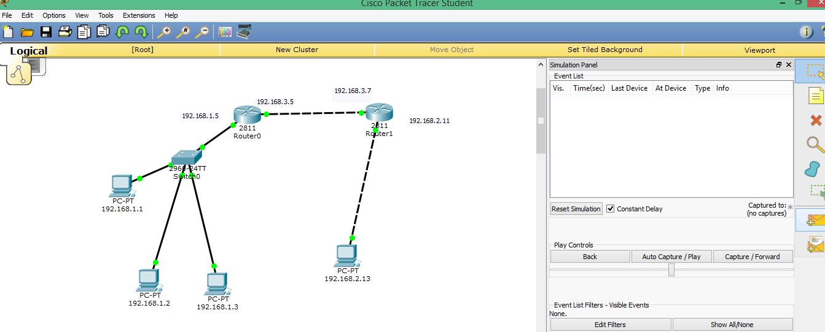

After, send a message from one pc to another pc.

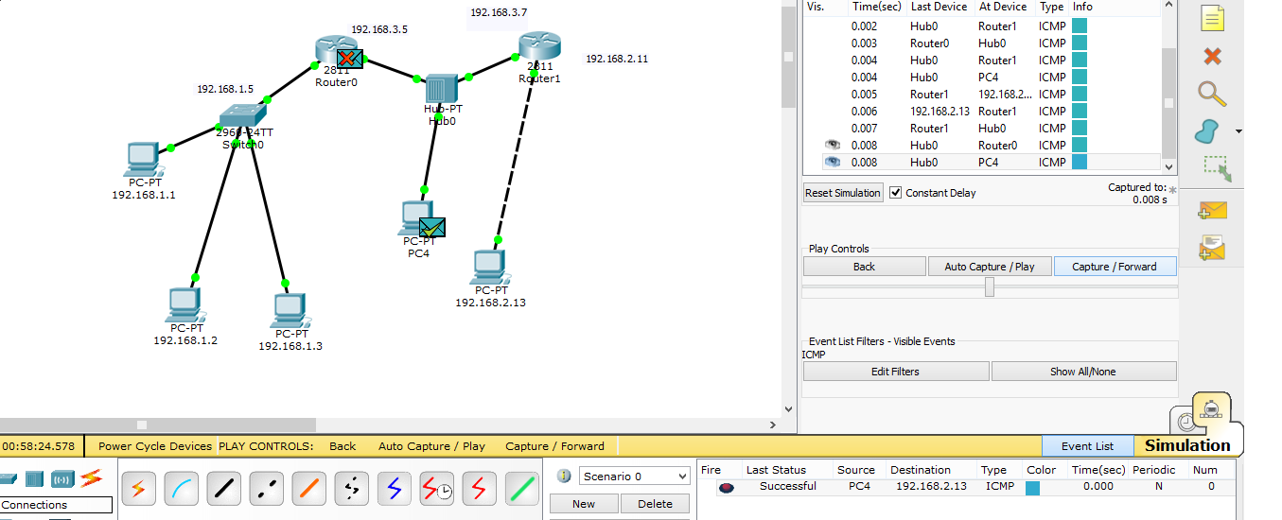

**Conclusion:** The overall process of delivering a packet from point A to point B is usually referred to as routing, and the devices primarily responsible for accomplishing this task are usually called routers. Essentially, it is a router's job to know where the packet needs to go next. You already know that routers use forwarding or routing tables to determine where to send a particular packet based on destination address.